000님 session 00
오픽 기출유형 분석집

In this lesson, you will work through two OPIc question types — Takeout/Delivery Food (장소묘사) and 롤플레이: 음식점. 매월 최신 오픽 트렌드 완벽 분석! · 2026년 최신.

Takeout/Delivery Food
오픽 시험 보기 전 반드시 확인해야 할 기출 유형 완전정복! · 꿀잼답변으로 첫오픽 IH+ · 종로 해커스오픽 클로이

A. 돌발 공부방법
- 모든 질문 두 번 재생
- a. 유형파악 b. 스토리라인
- 유사 주제 묶어보기

B. 유형 정리

Takeout/Delivery Food
1. Takeout/Delivery 식당 묘사
2. 최근 Takeout/Delivery 경험
3. 기억에 남는 경험

Restaurant
1. 자주 방문하는 식당 묘사
2. 최근 외식경험
3. 기억에 남는 식당에서의 경험

Holiday/Celebration
1. 우리나라 사람들의 Celebrations 설명
2. 최근 Celebrations 경험
3. 가장 기억에 남는 Celebrations 경험

C. 묶어보기

● Takeout/Delivery 식당 묘사
● 자주 방문하는 식당 묘사
● 최근 Takeout/Delivery 경험
● 최근 외식경험
● 최근 Celebrations 경험
● 기억에 남는 Takeout/Delivery Food 경험
(special occasions: a company meeting …)
● 기억에 남는 식당에서의 경험
● 가장 기억에 남는 Celebrations 경험

D. 실전연습

● Takeout/Delivery 식당 묘사
● 자주 방문하는 식당 묘사

Takeout/Delivery
Q. Please tell me about a takeout or delivery restaurant that you often order from. Why do you like that restaurant? Are there any specific reasons? Please give me all the details about the restaurant.

Restaurant
Q. Is there a restaurant that you often visit? Where is it located? Are there any special dishes that you enjoy the most? Why do you like that restaurant? Please tell me everything about your favorite restaurant.

E. 유형파악
● 장소묘사
● 답변분량: 1분 미만 ~ 초반
● 전략: 장소묘사 템플릿

F. 장소묘사
이름: McDonald’s
장점 2개: 1) Location
2) Price

G. MBC 답변

M (Main)
Um, okay, I’d say McDonald’s is one of my go-to (takeout) restaurants.

B (Body)
You know, first of all, there are so many locations all over Seoul, where I live. I mean, I can easily find one and quickly grab a burger even in the middle of a busy day.
Um, what else? Oh yeah, the price.
As you know, it’s actually pretty affordable. I can usually get a combo for under ten bucks. You know, that’s a pretty good deal, right?

C (Conclusion)
So, for me, it’s convenient, quick, and budget-friendly. That’s why McDonald’s is one of my favorites.

H. 전체 MBC 정리

M: Um, okay, I’d say McDonald’s is one of my go-to (takeout) restaurants.
B: You know, first of all, there are so many locations all over Seoul, where I live. I mean, I can easily find one and quickly grab a burger even in the middle of a busy day.
Um, what else? Oh yeah, the price.
As you know, it’s actually pretty affordable. I can usually get a combo for under ten bucks. You know, that’s a pretty good deal, right?
C: So, for me, it’s convenient, quick, and budget-friendly. That’s why McDonald’s is one of my favorites.

I. 표 정리

McDonald’s
1) Location | (+), easily find one and quickly grab a burger
2) Price | Affordable, get a combo for under ten bucks, → a good deal
 | ∴ convenient, quick, and budget-friendly → McDonald’s

롤플레이: 음식점
오픽 AL 단기고득점 메이커 · 종로 해커스오픽 임지혜

A. 주제 구성
[문의하기] 식당에 전화해서 예약하기
[문제 해결하기] 잘못 나온 음식에 대해 컴플레인 하기
[관련 경험 말하기] 최근 외식 경험

B. 롤플레이 구조 (문의-문제-경험)

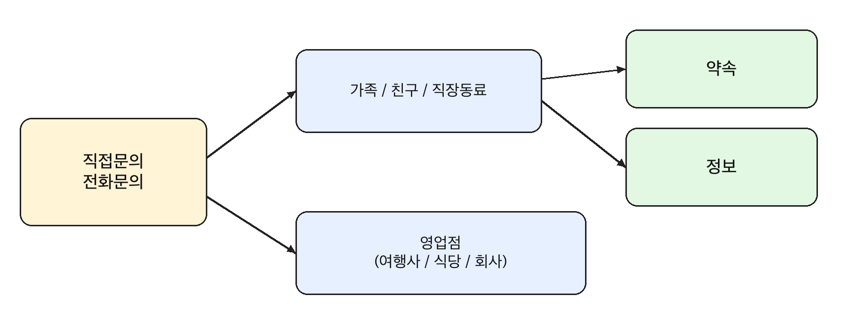

C. 롤플레이 : 레스토랑 전화예약

Question
Q) I’d like to give you a situation to act out. You need to make a reservation at a restaurant for an event that is coming up. Call the restaurant and ask three or four questions to make arrangements for the event.

Sample Answer

Hi, I’d like to make a reservation for five people.
1) Do you have any tables available this Saturday evening?
2) Would it be possible to get a table outside?
I’m planning a small gathering with about five people.
3) Also, could you tell me if you have a private room or a quieter area?
It’s kind of a special occasion, so I’d prefer a more comfortable setting.
4) And I was wondering if you offer any group packages.
5) If so, what options do you recommend?
What’s included in the package? Could you tell me the price range?
By the way, is it possible to make any special requests,
like decorating the table or bringing a cake?
Also, could you let me know what times are available and how long we can stay?
(oh, really?) That sounds great.
I’d like to go ahead and make a reservation. Thank you!

D. 롤플레이 : 잘못 나온 메뉴 컴플레인 하기

Question
Q) I’m sorry, but there is a problem I need you to resolve.
You’re at an international restaurant and ordered some food.
However, you found out that you’ve got the wrong order.
Speak to the manager about the problem and give
two or three alternatives to handle the situation.

Opening

Excuse me, I think there’s been a mistake with my order.
I ordered the chicken pasta, but I was served a seafood dish instead.
Could you please check my order?

Continuation
I’m a bit concerned because I can’t eat seafood.
Would it be possible to replace this with the correct dish?

Or, if that’s going to take a while, could you cancel this order
and just remove it from the bill?

Also, if possible, could you offer a quicker alternative,
like a similar pasta dish that can be prepared faster?

I’d really appreciate it if this could be taken care of quickly.

E. 롤플레이 : 문의하기 필수패턴

물건 구매하기
[가격] How much is this? / Could you tell me the price range? / How much does it cost?
[색상] Do you have this in a different color or size? / Does this come in white?
[기능] Could you tell me more about the features of this phone?
[할인] Is there any discount available right now?
[시착 가능] Would it be possible to try this on / test it out?

약속잡기
[시간] Are you free this weekend? If so, what time works best for you?
[시간] Does Saturday evening sound good to you?
[의견] What do you feel like doing?
[의견] What should we do together?
[의견] Do you have anything in mind?
[의견] Do you want to grab coffee sometime?
[장소] Where should we meet?
[장소] How about meeting near your place? / Do you have any place in mind?

F. 롤플레이 : 문제 해결하기 필수패턴

교환, 환불, 컴플레인 하기
› I’d like to return this item.
› I’d like to exchange this for a different size/color.
› There seems to be a problem with this product.
› Could you tell me what my options are?
› Is it possible to get a refund?

약속 취소 / 변경
› Something has come up, so would it be possible to reschedule?
› Hey, something came up. Can we reschedule? How about tomorrow?
› Could we reschedule the meeting?
› Would it be possible to move our meeting to another time?
› I’m sorry, but I have to cancel our plans.
› Do you mind if I take a rain check?
› Does another day work for you instead?

